Threat Intelligence Sharing Platform Implementation using MISP
In propose work employing MISP (Malware Information Sharing Platform & Threat Sharing) framework to detect threats from organization environment. This tool will be listening on all activities which are perform online such as invalid login to admin account, reaching or accessing to IP or domain which contains malware contents and then block users from accessing such domains.
In organizations employees are allowed to access their own accounts but sometime some malicious employees may try to login to higher authority account and such activities can be detected using MISP.
Often employees allow to access online web resources and those resource domain may contain harmful malware which can corrupt server. MISP will monitor all browsing domain and then restrict user from accessing online such domains and then share all threat detected domains with other users
To implement this project we have designed following modules
- Admin Login: admin can login to system using username and password as ‘admin and admin’. After login admin will add employee details and issue login details to employee for accessing accounts
- View Threat Log: using this module admin can view all browsing logs which are access by employees. This log automatically share with all users whatever activity perform by one user. By using this log admin and other employees can know which domain is harmful or normal
- Visualize Threat Activities: using this module admin can visualize how many threats and normal activities perform by employees
Employee Modules
- Employee Login: employee can login to system using username and password given by admin
- Access Web Resources: using this module employee can access desired domains and then MISP will monitor all those domains to alert employees
- View Share Threats: can view all threats access perform by employees
To run project install python 3.7.2 and then install all packages given in requirements.txt file. Install MYSQL database and then copy content from db.txt file and paste in MYSQL console to create database.
SCREEN SHOTS
Now double click on ‘run.bat’ file to start python server and get below page
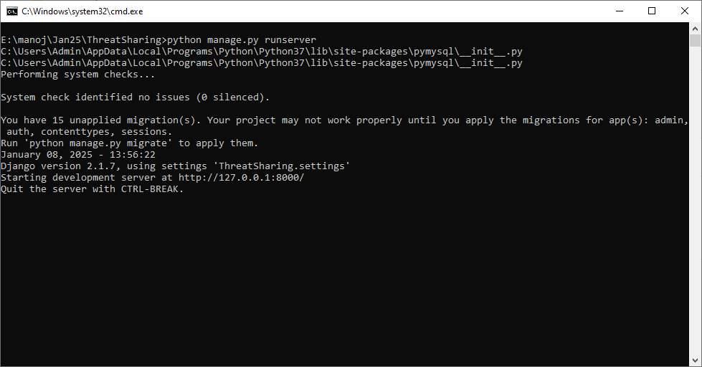
In above screen python web server started and now open browser and enter URL as http://127.0.0.1:8000/index.html and then press enter key to get below page
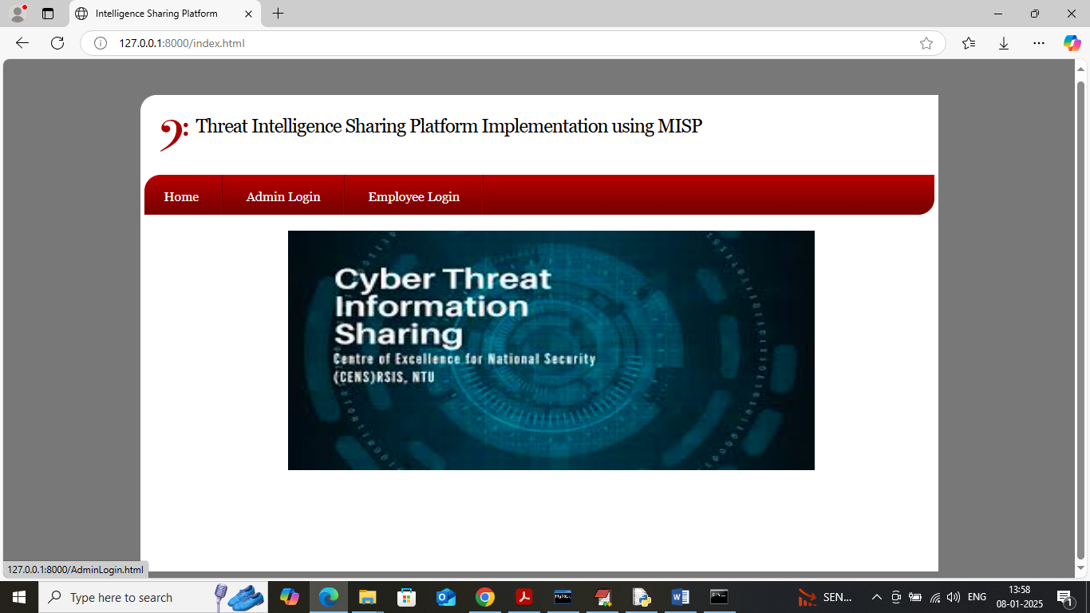
In above screen click on ‘Admin Login’ link to get below page
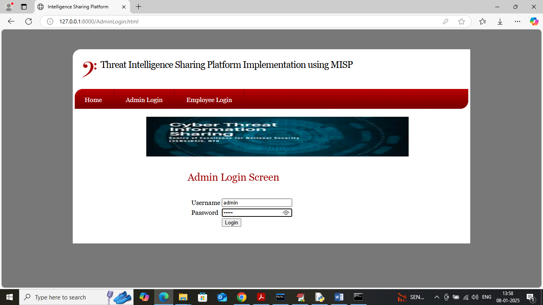
In above screen admin is login and after login will get below page
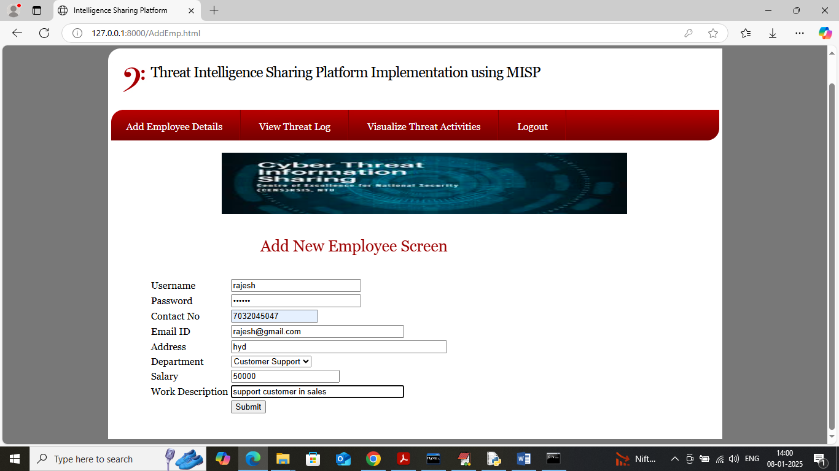
In above screen admin is adding employee details and then press button to get below page
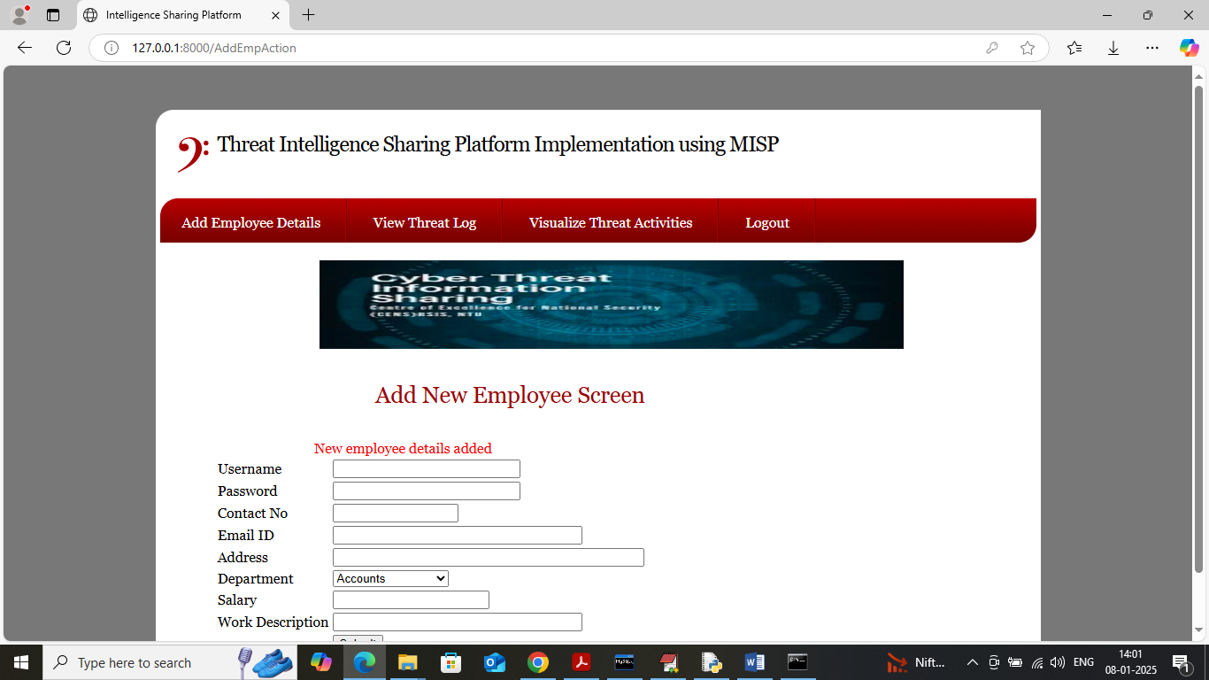
In above screen employee details added to database and now admin can click on ‘View Threat Log’ link to view all activities done by his employees
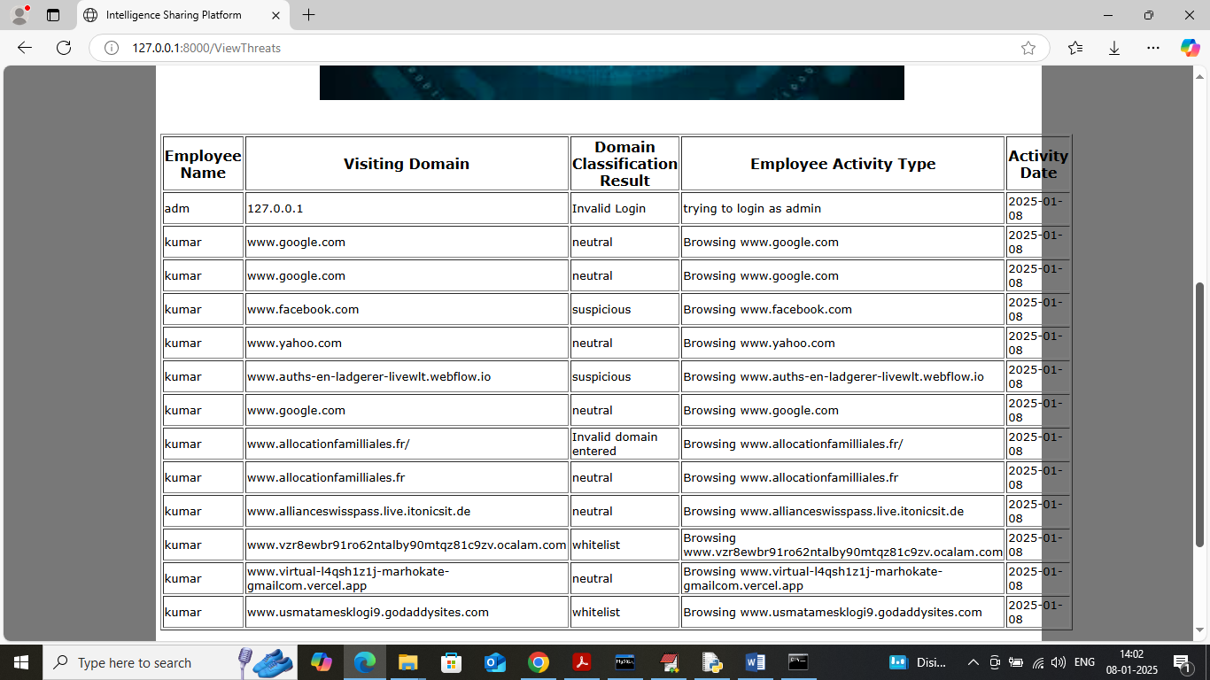
In above screen admin can view all threats access domain activities done by employees along with username. In above screen domain access classification is done by using MISP ML module. Now click on ‘Visualize Threat Activities’ link to get below page
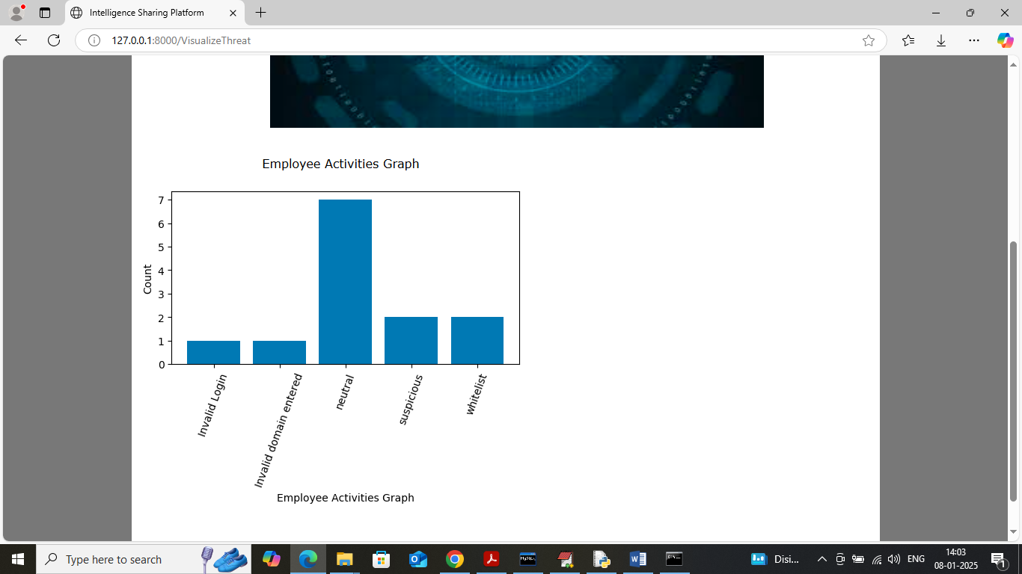
In above screen admin can view activities graph where x-axis represents ‘type of activity’ detected by MISP and y-axis represents counts. Now logout and login as employee
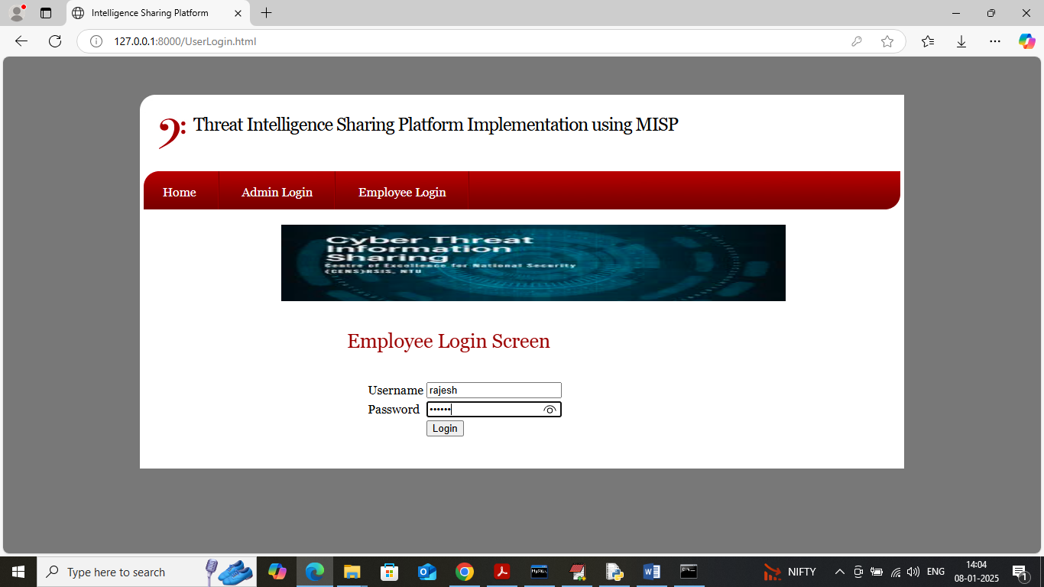
In above screen employee is login and if employee enter invalid login then that also detected and added to logs and after login will get below page
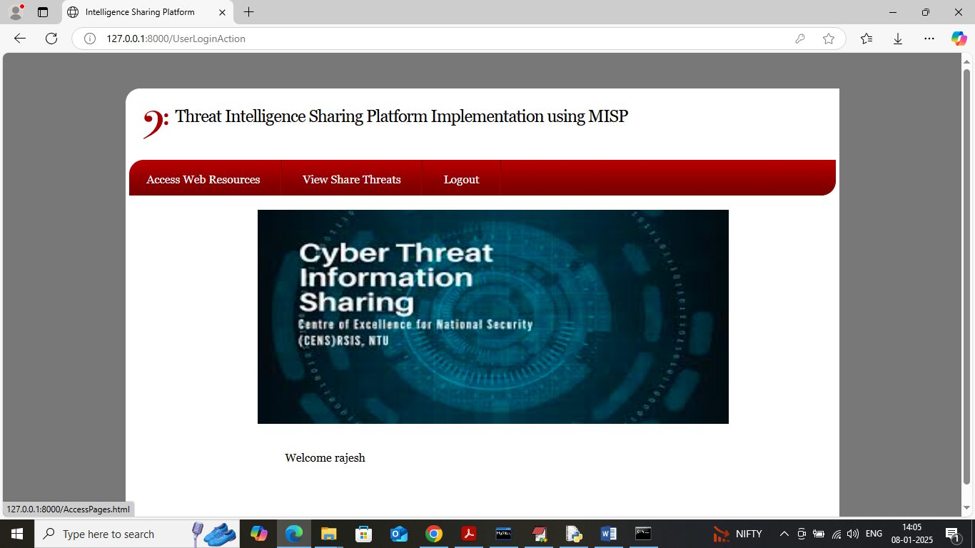
In above screen employee can click on ‘Access web Resources’ link to get below page
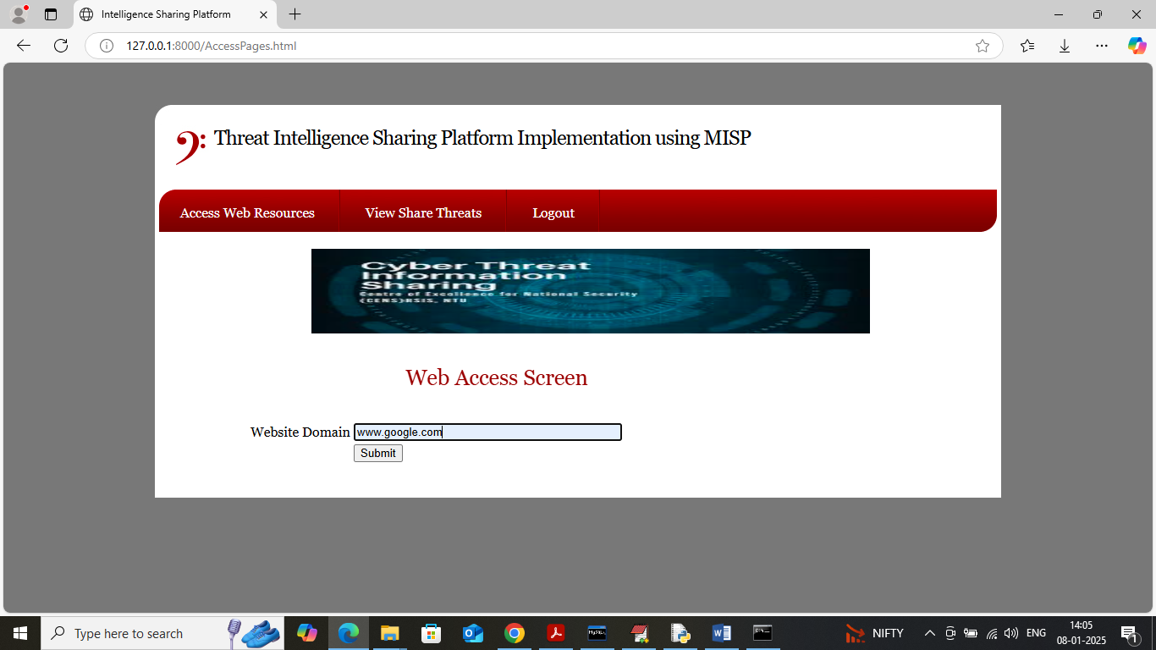
In above screen employee will enter names of domain which he wants to access and then MISP will monitor above domain and then alert employee with below response. (Note: in real time employees will not have free access to browser and they have to access using office provided browser software).
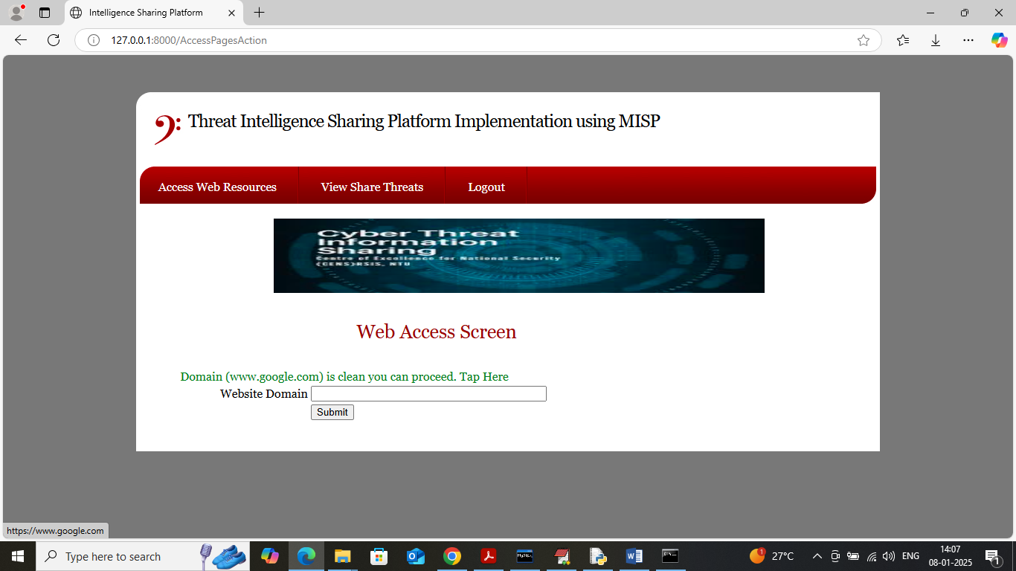
In above screen MISP generated response in green colour by saying ‘domain is clean and employee’ allowed to access so employee can click on that green text to access resource. Now try another URL
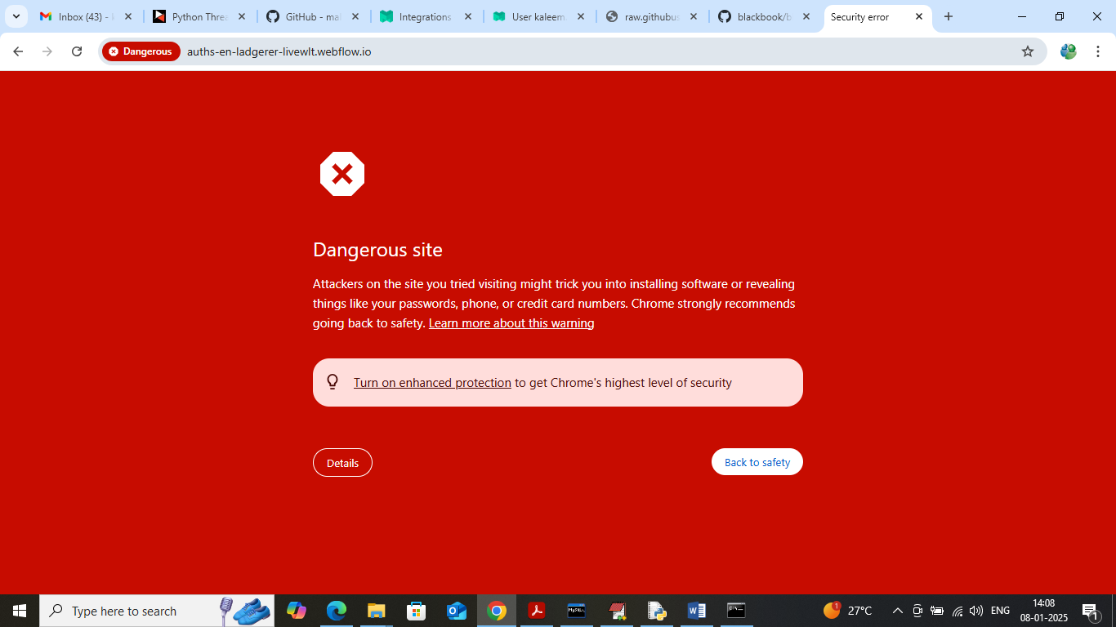
In browser you can see above URL is danger to access which is alert by chrome and now same URL will test with MISP in below page
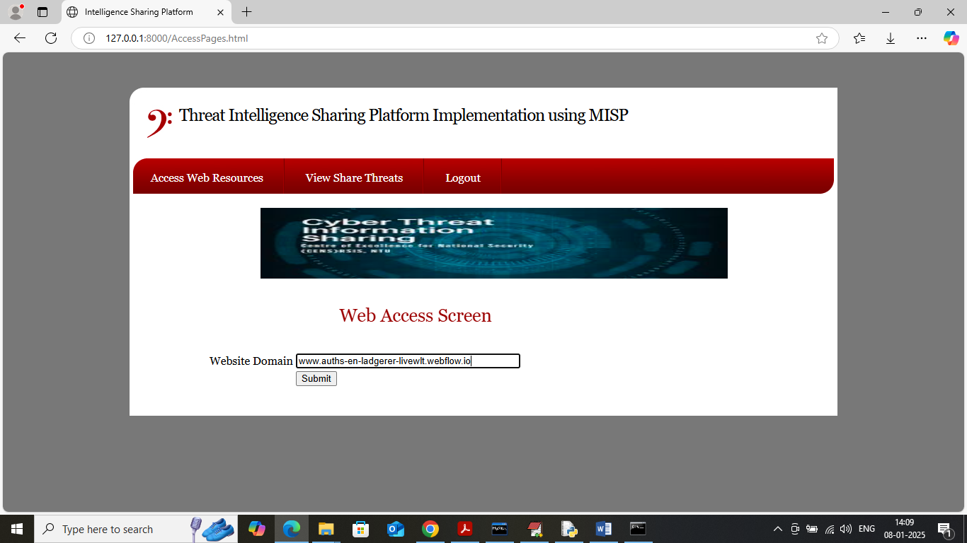
In above screen employee is trying to access harmful malware page and below is the MISP response
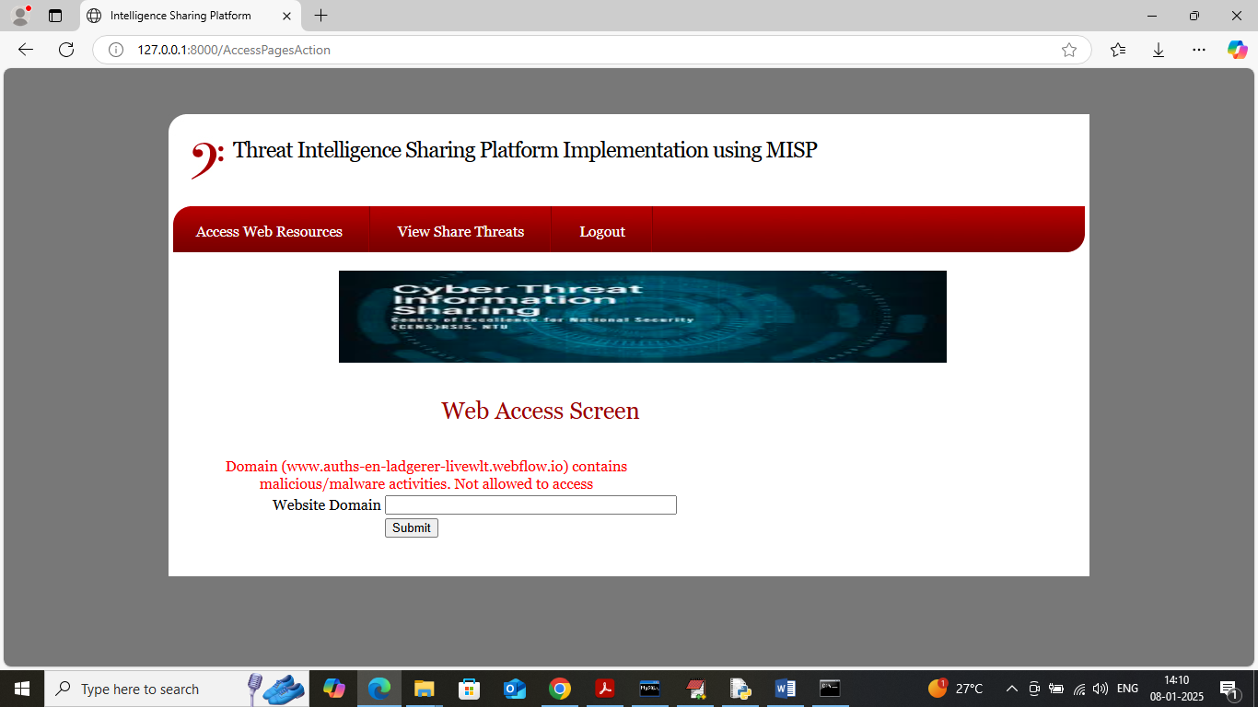
In above screen MISP responded with red colour text saying ‘Not allowed to access’. (note: we kept some malicious URL inside code folder which you can use for testing and this filename is ‘malicious-url.txt’).
Now click on ‘View Share Threat’ link to view all threats access share and perform by other employees.
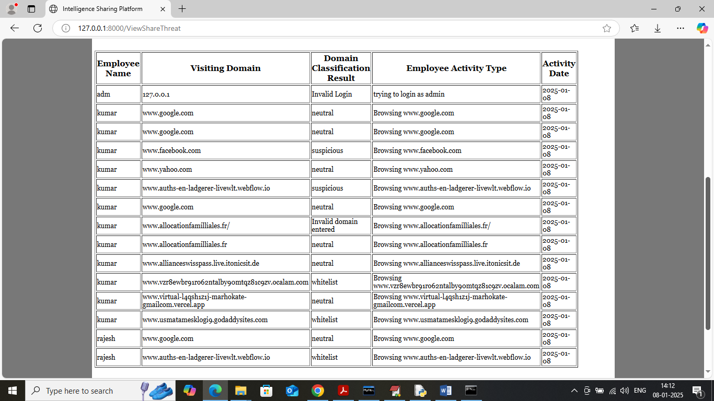
In above screen employee can see all types of activities share from other employees.
Similarly by following above screens you can save server from accessing malware based domains.

